January 2019
Cover Crop Corner: Frost seeding gives pastures a head start
Now is the time to start thinking about your spring forage
By Jerry Hall, director of research for Grassland Oregon
Every time we get to January 1st it’s hard not to notice how quickly the year has passed by. Wasn’t it just a few weeks ago when we finished haying?
Even though the ground may be frozen or covered with snow where you live, the turn of the year means it is time to seriously start mapping out your spring and summer forage plan. This also means it’s the perfect time to think about dormant seeding hay, silage and pastureland with a legume. Extended growing seasons, higher yields and feeding quality, along with increased establishment rates and convenience are just a few benefits frost seeding can bring to your farm or ranch.
When a legume is frost seeded, it is broadcasted onto the frozen surface of the soil – preferably with no snow cover. As soil follows a freezing and thawing cycle, seed will work into the top 0.25 inches of soil. Since the clover seed can germinate and start growing once weather becomes favorable instead of having to wait until soil firms up enough to get drilling equipment into the field, frost seeding can increase establishment.
Before giving frost seeding a try, it is important to do your homework on seed selection, only choosing cold tolerant varieties that will survive subfreezing temperatures. Traditionally, red clover is one of the most popular legumes for frost seeding because of its cold weather hardiness. However, improved plant breeding is bringing more species into the frost seeding offering.
One of the most recent developments is Frosty Berseem Clover, the first cold tolerant berseem clover on the market. Prior to its development, the ability to capture the benefits of both frost seeding and berseem clover into one system hasn’t been possible. But with the ability to thrive in temperatures as low as 5 degrees Fahrenheit and zero snow cover, a cold tolerant berseem clover allows for the best of both.
Frosty Berseem Clover is also one of the few clovers that doesn’t cause bloat, making it a great choice for livestock producers. In a trial conducted by Mississippi State University, it produced non-bloating forage with crude protein content of 20.5 percent. In a separate trial by Pennsylvania State University, the cold tolerant variety produced more than 4 tons of dry matter per acre in a two-cut hay system while fixing 150 pounds of nitrogen per acre.
Regardless of what species, varieties and planting methods are best for your forage system, don’t put off thinking about your spring forage until the ground starts to melt. With some early strategic planning and improved variety options, 2019 could be your best forage year yet.

--Ends—
Editorial Note:
Cover Crop Corner is a new educational column from forage application company Grassland Oregon and free for print or digital distribution by media outlets. To be added to the distribution list, please email laura@abccomms.co.uk.
TO DOWNLOAD HIGH RES IMAGES, CLICK HERE.

Images:
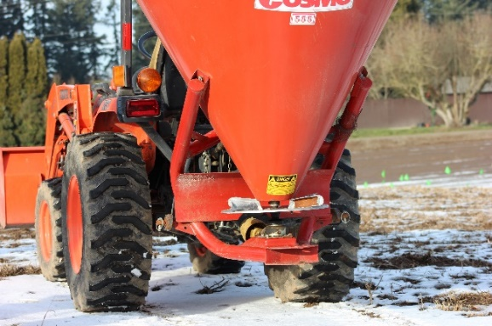

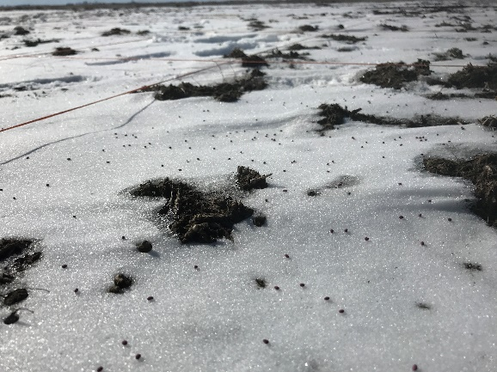

When seed is broadcasted onto frozen soil, the freezing and thawing cycle will work seed 0.25 inches into the soil. Once weather conditions become favorable, seed will germinate.

Cold tolerant clovers, like Frosty Berseem Clover, can be used to frost seed pastures.

