

PRESS RELEASE

ForeFront offers enhanced disease and stress resistance for better golf greens

Germinal will be showcasing its ForeFront Greens grass seed mixture at the BIGGA Turf Management Exhibition (BTME) in Harrogate from 22nd to 24th January 2019.
Containing a unique blend of three top-ranking bentgrass varieties, ForeFront Greens delivers the highest levels of disease and stress resistance. It is rated for cutting heights down to 3mm and, with excellent shoot density, fineness of leaf and unrivalled summer and winter greenness, is the mixture for better golf greens.

ForeFront Greens contains 35% Aber®Regal (browntop bent), 35% Aber®Royal (browntop bent) and 30% 007 DSB (creeping bent).

AberRegal and AberRoyal were both bred at IBERS (the Institute of Biological, Environmental and Rural Sciences in Aberystwyth) from parent material originally sourced in the UK. As well as superb disease resistance they also offer excellent shoot density, good fineness of leaf and unrivalled winter and summer greenness.

007 DSB was bred in the US using 24 parent plants to produce a single cultivar with a prostrate growth habit, high shoot density and good wear tolerance in a wide range of climatic conditions. 007 DSB has won plaudits wherever it has been used including at Ryder Cup and US Open courses and at the PGA Masters at Wentworth. Unlike older creeping bent varieties, 007 DSB has a lower requirement for water and nutrients thereby making it ideal for inclusion in a low input seed mixture.

The recommended sowing rate for Forefront Greens is 8 to 12g/m² (80 to 120kgs/ha). The recommended overseeding rate is 5 to 8g/m² (50 to 80kgs/ha).

To discuss how ForeFront Greens could benefit your course visit Germinal on Stand 257 in the Red Zone at BTME. Alternatively go to www.germinalamenity.com

-Ends-

Image supplied:
Alternatively, click thumbnail to download image in high resolution
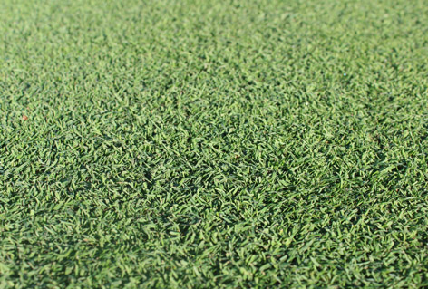
ForeFront Greens creates a sward with increased wear and heat tolerance and good all-round disease resistance.

28th November 2018

Notes to editors:
- ® Aber is the Registered Trademark of Germinal Holdings Ltd
- Germinal is a wholly owned subsidiary of Germinal Holdings Ltd - the largest family owned British and Irish Forage & Amenity Seed Company.
- Germinal provides a range of grass seed products and services designed to meet the specific requirements of the amenity industry. Customers include professional greenkeepers, turf growers, groundsmen, landscape contractors, golf course constructors, architects, agronomists and ecologists, all of whom deal directly with the only company selling British-bred turf grasses direct to the end user.
- Buying direct from Germinal gives our customers access to first class technical advice and great value specialist turfgrass products through the “Grade A” grass seed mixture brand. Customers can also purchase from a range of fertilisers and adjuvants as well our extensive range of UK Native wild flower seed mixtures.

Further information:
Richard Brown, Amenity Sales Manager, Germinal
T: 01522 868 714 E: richard.brown@germinal.com

Follow @germinalamenity for regular and topical information from our amenity division.

Issued by Paul Jennings, Agribusiness Communications Ltd
Tel: 01694 731777 E-mail: paul@abccomms.co.uk

The text from this news release can be downloaded directly from the ABC press centre at www.abccomms.co.uk

