Cover Crop Corner: The 12 gifts of cover crops
By Jerry Hall, director of research for Grassland Oregon
Give your crop or forage system the gift of cover crops this Holiday season
As we approach the time of year of giving gifts to the ones you hold near and dear, it may be worth considering what gifts cover crops can give your crop or forage system.
1. Restore soil
One of the most important, but sometimes forgotten components to a profitable system lies below the ground’s surface. There is an entire ecosystem within soil, determining how a plant interacts with microbes and available nutrients. When soil conditions aren’t right, then the communication between these components breaks down and your crop suffers as a consequence. However, cover crops can help drive this communication channel by improving soil health. Species like daikon radish and annual ryegrass have extensive root systems that drill deep into soil to break up compaction. This not only improves water infiltration, but the movement of air and nutrients deep in the soil. Exudates from the cover crop roots can either enhance or hinder biology in the soil, both useful depending on your goals.
2. Reduce erosion
The farm’s most valuable asset is its soil, which means holding the soil in place in order to capture and retain moisture from rainfall is one of the first steps in improving its health and productivity. By providing ground cover and deep root systems, cover crops help reduce land degradation from wind and water erosion. The living roots also enhance water management by protecting the soil surface from sealing and improving drainage of wet soils.
3. Nematode control
Thanks to advances in plant breeding, there are nematode control radish varieties that are 90 percent effective at controlling sugar beet cyst and Columbia root-knot nematodes without the need for a seed treatment. White mustard is also effective at controlling nematodes.
Regardless of what specie you decide is best for your system, only choose varieties that have been tested to verify they are not nematode hosts. Not all companies do this, which means you could inadvertently be inviting a new problem to your field. When dealing with important issues like nematode control, insist on third-party data.
4. Choke out weeds
Species with rapid growth during cool seasons are great at choking out weeds by providing a dense stand for soil shading. Compare the growth period of the weeds that you want to control with that of the cover crops available. Aggressive cover crops can easily smother problem weeds or inhibit weeds from germinating.
5. Benefit wildlife
Have dreams of bagging a monster buck next year? Want to improve your wild bird habitat? Cover crops can provide both solutions! Many of the annual clovers and other cover crops feature a lot of growth in the spring, a time when high crude protein sources are minimal. Scientific studies have shown that having a readily available high crude protein source in late gestation through weaning makes for bigger fawns which in turn make bigger deer. Many cover crop species are also great for attracting waterfowl and providing food and shelter to turkeys and other game birds.
6. Feed pollinators
Without pollinators, our food supply and economy would be greatly impacted. According to USDA, native bees contribute $9 billion and hived bees contribute $15 billion to the economy by pollinating crops. However, habitat loss has greatly contributed to the decline of pollinators. By incorporating a variety of annual clovers, vetch, and brassicas with different flowering dates into your forage mix can provide pollinators with a productive environment while cashing in on the forage benefits. If you’re curious to know more, check out pasturesforpollinators.com.
7. Grow more profitable alfalfa
Speaking of interseeding clovers… here’s one for the alfalfa growers. Research in Saudi Arabia found the synergistic relationship between berseem clover and alfalfa significantly improves quality and yield of forage when seeded at a mixture ratio of 80 percent alfalfa to 20 percent berseem clover. We have obtained similar results here in USA trials. A multi-cut berseem clover, like Frosty, makes a great nurse crop for new seedings and can also enhance and thicken declining stands. While alfalfa stores its energy in the root, berseem clover stores its energy in the base of the plant. Just remember to not cut too low (2-3 inches) so the berseem clover can recover and regrow.
8. Improve ROI on corn production
If you had the chance to cost effectively increase your corn yield by 12 bu/acre while receiving free nitrogen and nearly 300 pounds of added biomass/acre would you do it? In a 2015 trial by The Ohio State University, corn interseeded with FIXatioN balansa clover at the V6 stage achieved just that, compared to the control group. In the following year, corn following the FIXatioN plots realized a 20 bu/acre improvement over the control. This just goes to show that cover crop benefits can be realized for multiple seasons off one sowing.
9. Maximise wheat cattle efficiency
Grassland Oregon’s research partners at Mississippi State University found that stocker steers grazing wheat planted with balansa clover had a 0.82 pounds per day weight gain advantage to steers grazing annual ryegrass systems planted with balansa clover. Wheat also yielded the most biomass with 3,309 pounds DM per acre during the trial compared to annual ryegrasses 2,626 pounds DM per acre yield. Adding a late flowering annual clover to your winter forage can greatly improve your bottom line.
10. Reduce input costs
There’s a lot of financial gain to be had by reducing input costs, rather than throwing everything at a crop to achieve the highest yield. While establishing a cover crop will require capital, the return on investment will make it worth it. Legumes can add substantial amounts of nitrogen to soil – think upwards of 100 pound of nitrogen per acre. In a study conducted at the Ewing Demonstration Center in Illinois, decomposing FIXatioN balansa clover was able to improve the soil nitrate and soil ammonium ppm by 40 percent and 80 percent versus the control in just four weeks after corn emergence. Non-legumes are useful for absorbing excess nitrogen from the previous crop, leaving it in the field for the following crop. Not to mention the soil structure benefits and added organic matter going back into the field.

11. Add more tools to the toolbox
The more research that goes into breeding better cover crop varieties, the more tools you have in your business’ toolbox. The first priority that must be made when choosing your cover crop “tool” is to focus on variety traits rather than selecting based on specie. This is no different to choosing a variety of corn or the bull you want to sire your heifers – genetics are everything. It also highlights the importance of selecting for consistency of performance to ensure there is no variation in yield, and cover ratios.
Selecting for variety traits also gives you more management options. For example, late maturity was specifically bred into Grassland Oregon’s balansa and berseem clover varieties to give producers more management options. Because of this, if the cover crop needs to be terminated but weather conditions won’t allow you into the field, you aren’t at risk of the crop becoming reproductive and turning into a weed.
12. Create a more sustainable system
As environmental, political and social pressures intensify on the agricultural industry, sustainability must be at the forefront of management decisions. From looking after soil health to improving business profitability, taking a holistic approach to cash in on the 12 gifts of cover crops is a good way to create a more sustainable system.
From all of us at Grassland Oregon, we wish you a Merry Christmas and Happy New Year.

-Ends-
Editorial Note:
Cover Crop Corner is a new educational column from forage application company Grassland Oregon and free for print or digital distribution by media outlets. For more information or to be added to the distribution list, please email laura@abccomms.co.uk.

TO DOWNLOAD HIGH RES IMAGES, CLICK HERE.
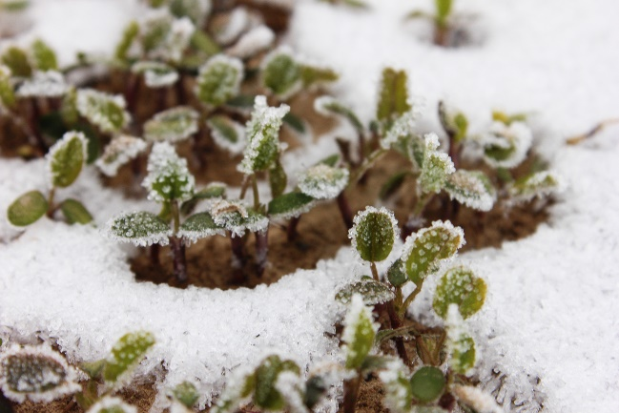

Image: Create a sustainable system
Caption: From improving crop yields to boosting forage quality, cover crops can help create a more sustainable and profitable system.

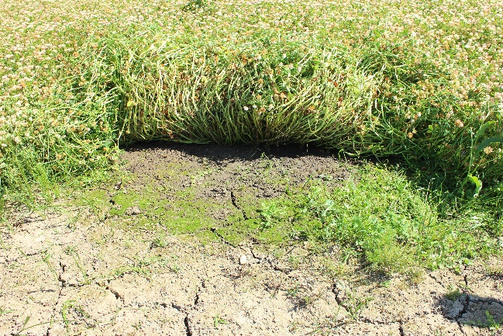

Image: Reduce erosion
Caption: By providing ground cover and deep root systems, cover crops help reduce land degradation from wind and water erosion.

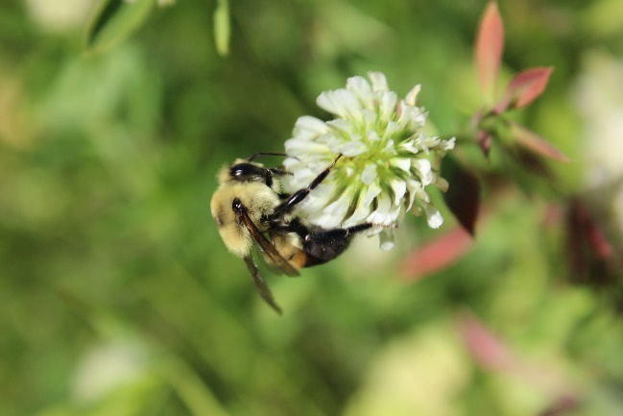

Image: Feed pollinators
Caption: By providing ground cover and deep root systems, cover crops help reduce land degradation from wind and water erosion.

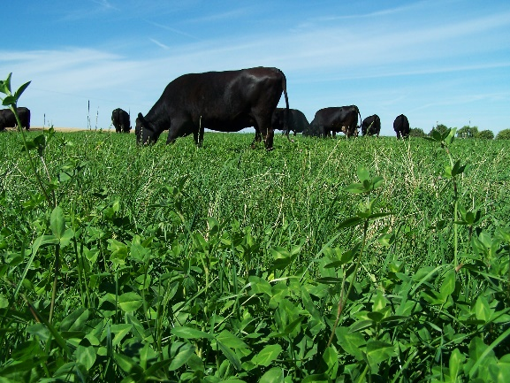

Image: Maximise cattle efficiency
Caption: Adding a late flowering annual clover to winter forage can greatly improve livestock performance while reducing input costs.
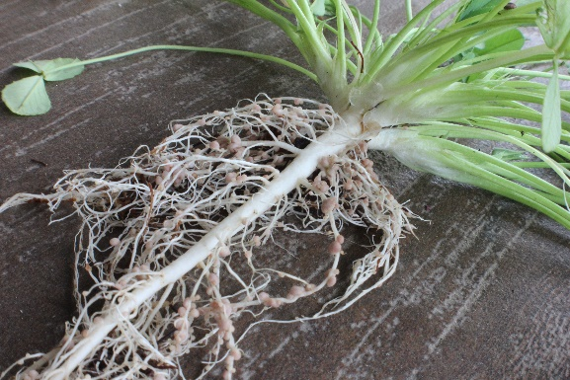

Image: Reduce inputs
Caption: Legumes, like FIXatioN balansa clover, can add upwards of 100 pound of nitrogen per acre.


Image: Jerry Hall, Director of Research for Grassland Oregon

